We Need to Stay Healthy

(a COVID19 social story)

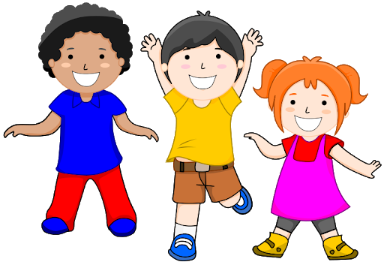

Created by Benjamin Donson MSED BCBA

Today I learned that I will stay at home for at least the next 2 weeks.

This is because some people are becoming sick

from a virus.

A **virus** is a kind of tiny living thing that can make people sick if it gets into **noses** or **mouths**.

I may feel sad, but we have to **stop** going to **school** for a little while and **stay** at **home**.

**school**

Here are **things I need to do** to keep my family and friends healthy until the virus stops bothering us.

1. I can wash my hands before and after touching things.

1. I can keep my hands and feet to myself.

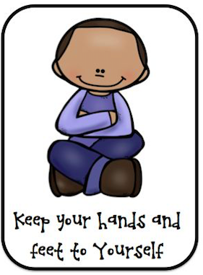

1. To say hello, I can bump elbows,

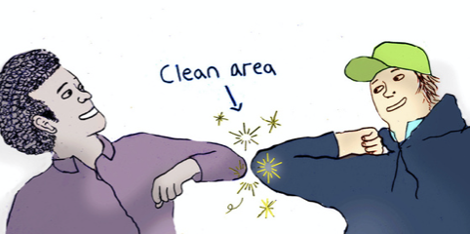

share a smile OR

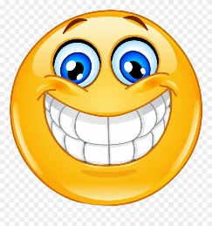

flash a peace sign

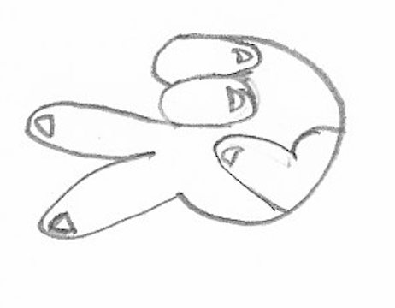

While I am home:

1. I can do work from my school teachers.

2. I can play with toys.

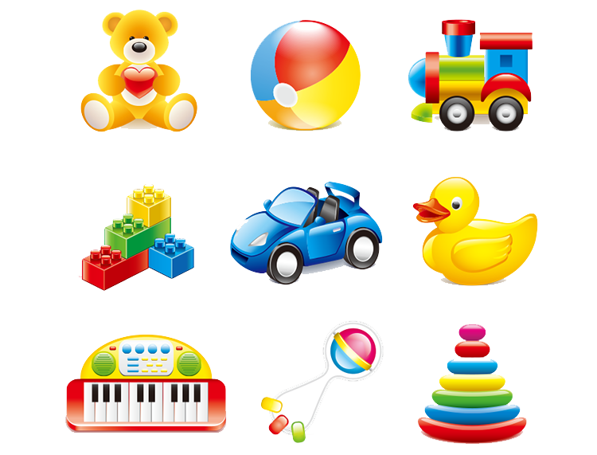

3. I can go for a walk outside with a family member.

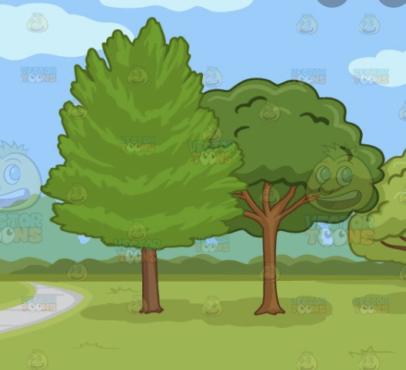

4. I can watch videos like 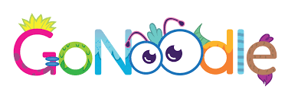

5. I can read books with my family. 

After the virus stops, I get to go back to school.

My friends and classmates will come back to school

at the same time I do.

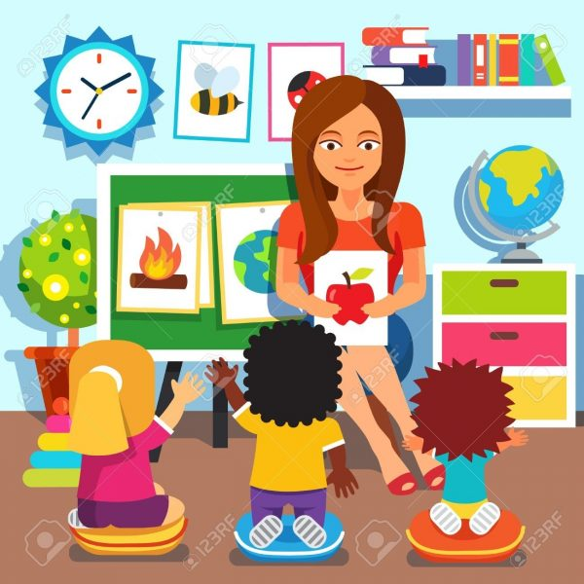

We will

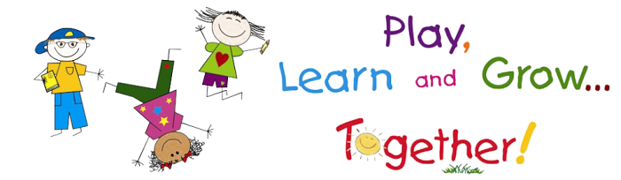

again Soon!